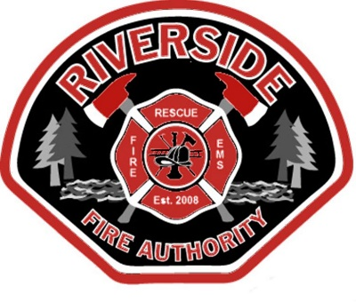

**Riverside Fire Authority**

**Fire Commissioners’ Meeting**

**AGENDA**

**December 25, 2024**

**Station 2**

**Conference Room**

**1818 Harrison Ave.**

**Centralia, WA 98531**

**360-736-3975**

**Board of Fire Commissioners**

Joe Dolezal

Position No. 1

(2020-2025)

Richard Mack,

Position No. 2

(2024-2025)

Mike Tomasheck,

Position No. 3

(2022-2027)

Buddy Lowrey,

Position No. 4

(2024-2029)

Mike Rossow,

Position No. 5

(2024-2029)

**5:00 P.M. Call to Order**

Buddy Lowrey, Chair

Richard Mack, Vice-Chair

1. Pledge of Allegiance
2. Approval of Agenda (additions/deletions)
3. Public Input or Comment
4. Consent Agenda:
5. Meeting Minutes ()
6. Voucher Approval ()
7. Payroll

5. **Unfinished Business**

6. **New Business**

a.

b.

c.

**Good of the Order**

**Adjournment**

**Administration**

Kevin Anderson,

Fire Chief

Erik Olson,

Assistant Chief

Stephanie Slorey,

Business Administrator/

Board Secretary

Misty Henning,

Finance Officer/

Asst. Board Secretary

Laura Hanson,

Volunteer Coordinator